SENTENCE/CONTEXT:

WORD:

PREFIX | ROOT(S) | SUFFIX

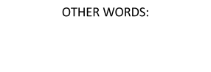  GUESS what the word means:  OTHER WORDS |  | Actual DEFINITION:
PREFIX | ROOT |  | SUFFIX
Sentence with one of other words:

Sentence with vocabulary word:

